Improvements based on feedback from design meeting with client Mike Gallagher.
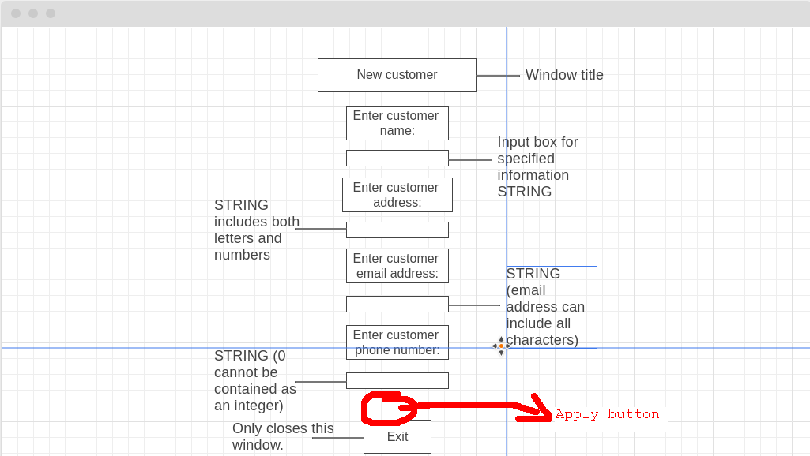
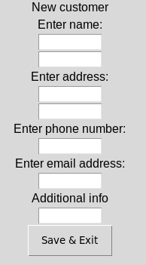
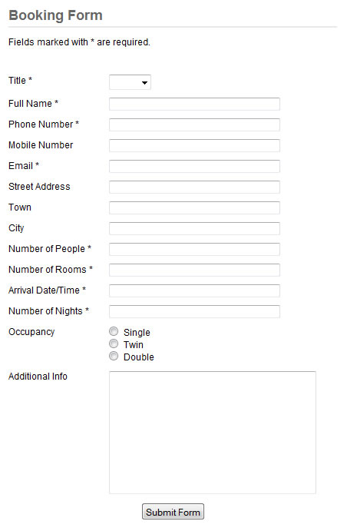
The customer menu has been updated according to the discussion with Mike regarding the fields and options that should be included. One feature that Mike mentioned multiple times was a save and exit button. This has been added, and should allow the user to commit changes to the database and close the window at the same time, creating a further streamlined experience when staff use the application. The updated button can be seen above alongside new fields, featuring: Firstname, surname, address1, address2, phone number, email address, and additional info. Mike and I also discussed the additional fields, regarding the separation of address line 1 from 2. In response to this, an additional field was added, accommodating for the new field. An example of address separation in other booking systems can be seen in this image, providing a more simplistic layout and process, by splitting address into different fields such as: city, town and address, making booking more efficient and detailed.
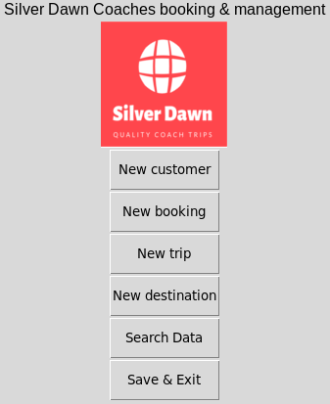
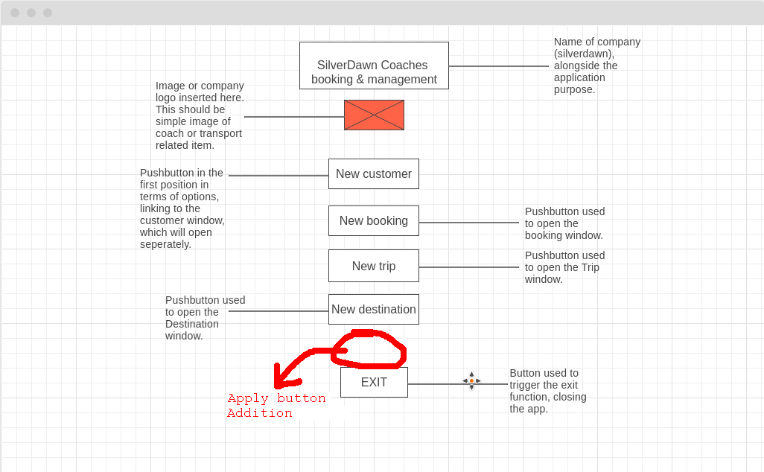
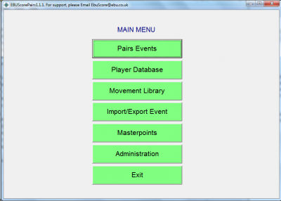
The main menu system has also been adapted, with the removal of discussed features such as an apply button, as seen here in the initial design, alongside the updated exit button, which has yet again been changed to save and exit, clarifying the function of each aspect of the menu. Most applications feature a dedicated exit button for convenience purposes, for example this sports database application, which features a similar layout to my application alongside an outlined exit button seen below:

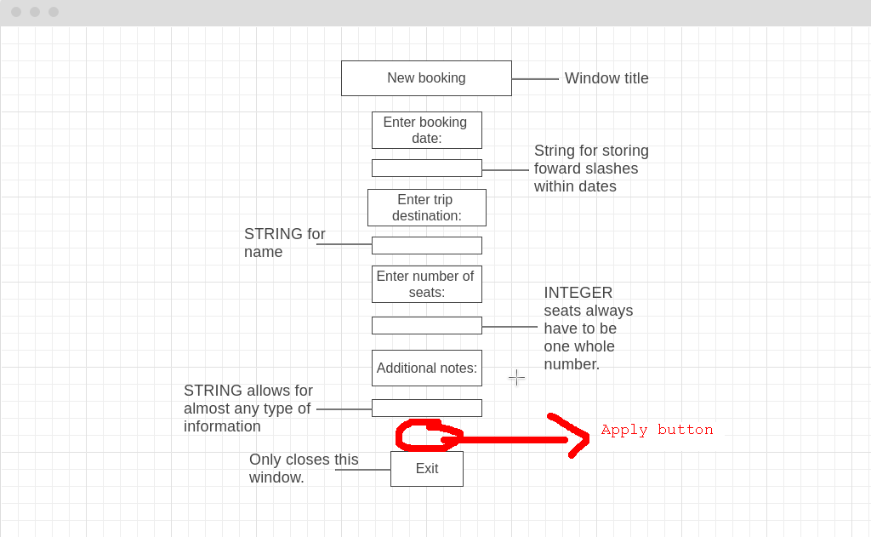
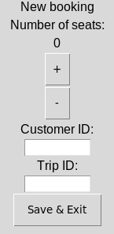
The booking menu was also discussed during the design meeting, with one of the main points collected from the meeting minutes being: the system date automation. This should be added into the finished design, removing the need for the booking field. This yet again removes unnecessary clutter from the application, and further optimises it for heavy use, with automated features, removing the chance for human error. Another noticeable change is the addition of an iterator, allowing the seat number to be changed in a user friendly way, acting as a form of validation to prevent erroneous data entry. An example of another application using a similar function is google’s sign up page: where data can only be selected based on certain fields.
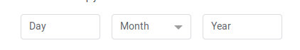

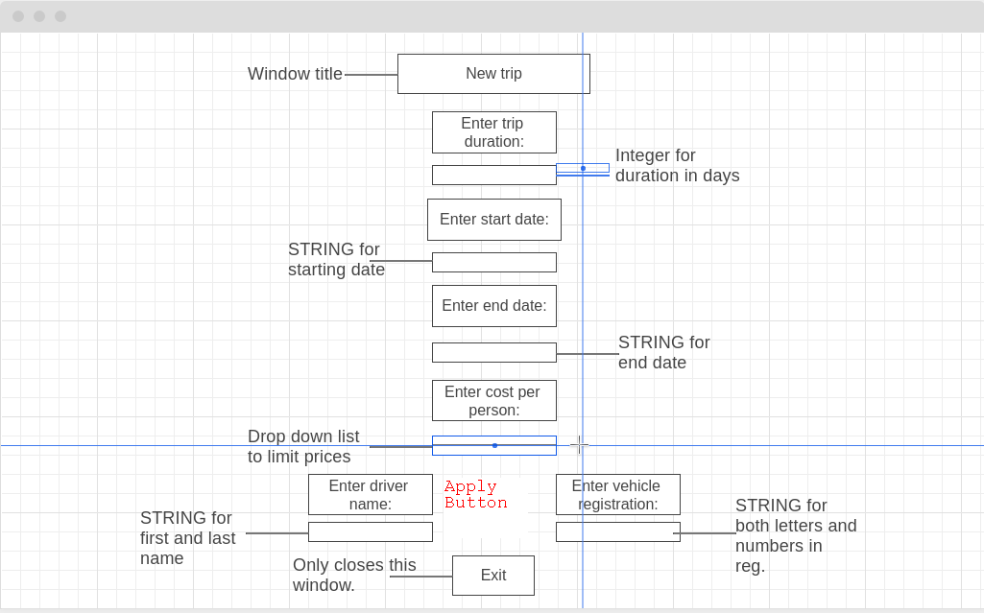
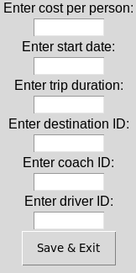
Finally, Mike discussed the trip menu, and upon inspection, the end date should be removed and instead start date and duration will be used to calculate the end date. This can be seen in the updated design:

Alongside this, the vehicle registration and driver name were also removed, as a result of the decision to normalise both the driver data and vehicle data. This essentially removes irrelevant data from this section of the application, and instead will use primary keys as seen in the updated version of the design.

